Materials in an engineered product

Introduction:

The product I will be looking at is a keyboard. The keyboard’s function is to send electronic signals into the computer so it will perform a specific function (moving charterer in a video game or entering text into Microsoft word.

Components:

The components I will be looking at are the keyboard case and the acetate PCBs inside.  
The case is the outside plastic that protects the inside components like the acetate PCBs but at the same time must house the keys. The acetate PCBs are of course the part of the PCB that will pass electronic signals around the keyboard. The way it is designed means that when the keys get pressed the dots of copper wire in both of the PCBs are pushed together through the gaps in an acetate spacer to create a circuit that make the electronic send the signal and therefore ‘presses’ the keys

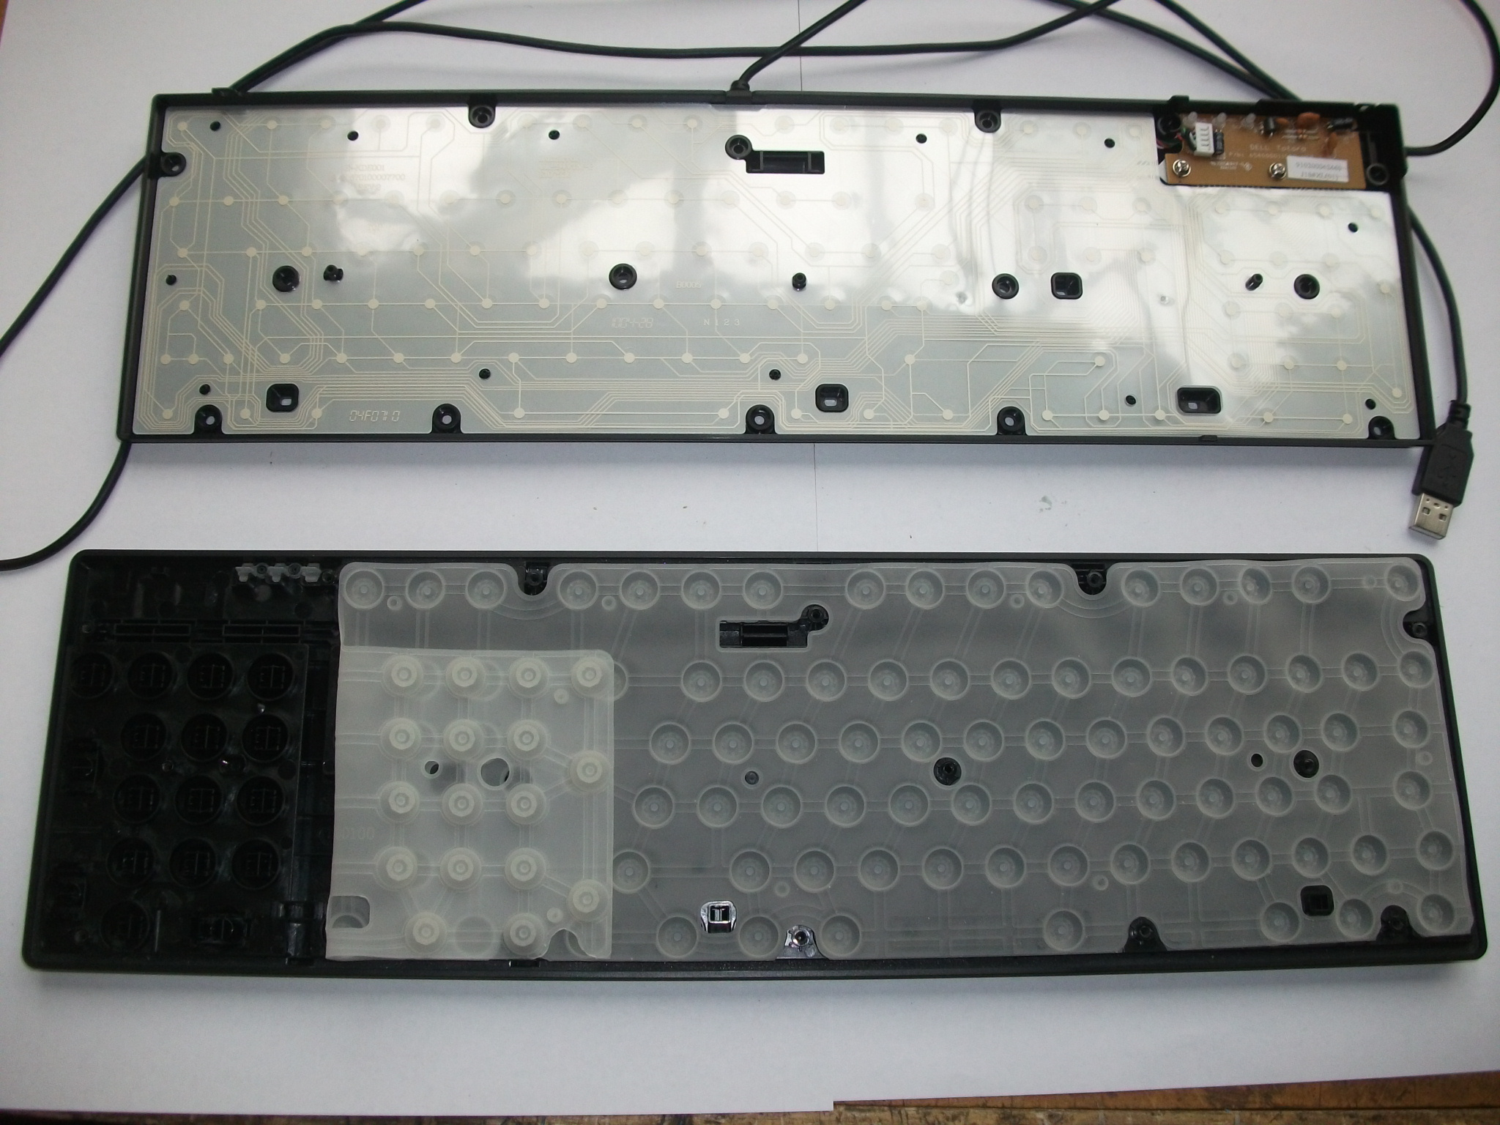

Copper connection ‘dots’

Acetate in the PCB

Copper connection

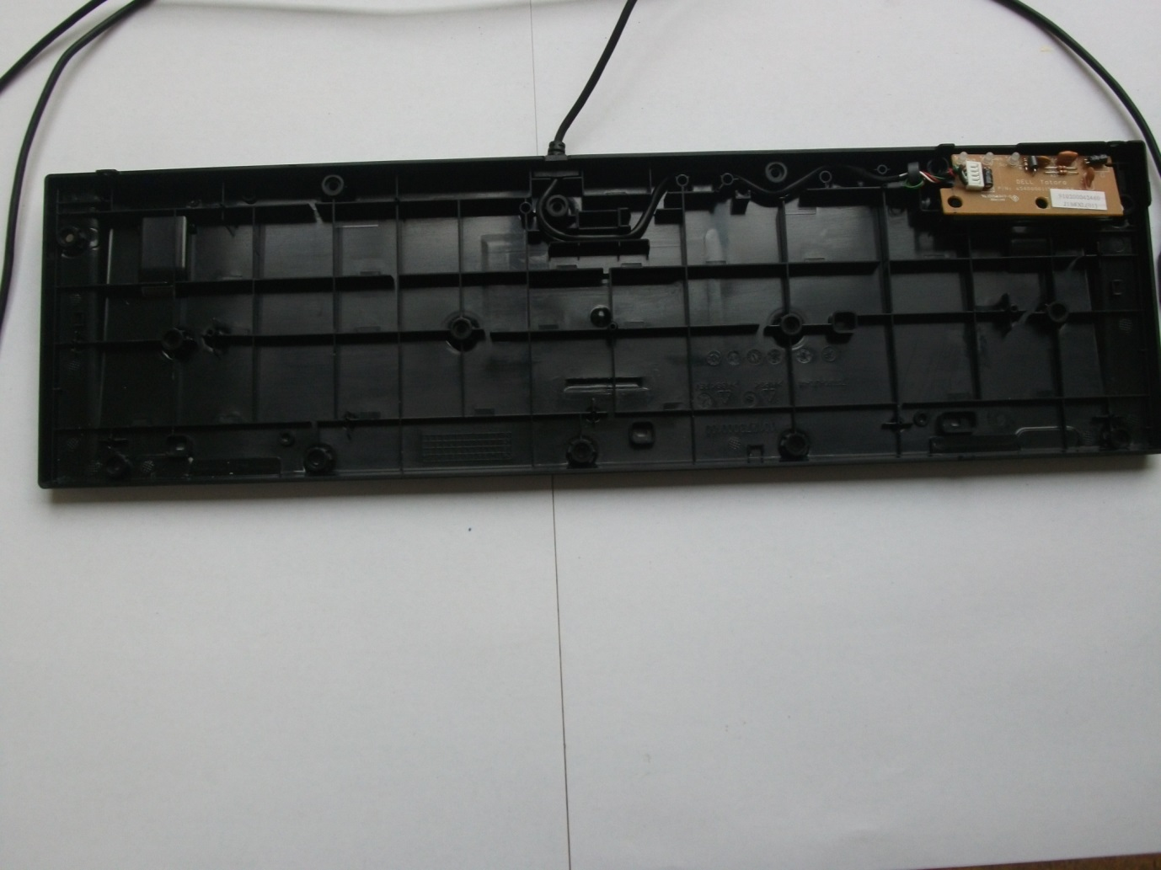

ABS on keyboard case

Ribs in the case

Materials

|  |  |  |  |
| --- | --- | --- | --- |
| Competent | Materials | Properties | Qualities |
| The PCB in the keyboard | Acetate for the board and the copper for the connections | Flexible, can be cut very thinly, durable, can be printed on. | Easy to obtain, Cost effective, durable |
| The Keyboard case | The entire case is made of ABS | Very sturdy, light weight | Cost effective, easily obtainable |

Environmental impact

The environmental impact for both of the component is very heavy as they are both plastics and there must be extracted from a well and brought back to a refinery. This can lead to a lot of some very serious impacts on the environment if done in correctly in the form of and oil spill. The two ways that an oil spill can happen is that 1 that an oil tanker can spill or 2, that the oil well will malfunction and oil spout up from underneath the sea bed. Second is generally the worst as it will mean that there has to be more than a simple clean-up operation they would have to fix the malfunction and that would take a while and during this oil would be spouting up into the sea.

The major problem with and oil spill is the effects it has on the wildlife around it as it will kill most wildlife and vegetation in the surrounding sea. Another problem is with the clean-up operation because the easiest and quickest way is to burn the oil off the surface. This method would lead to an environmental disaster as it would release incredibly large amount of carbon emissions.

The second environmental impact comes from the refining processes that require a large amount of heat to separate the oil fractions which would need a large amount of energy. It is this need for energy that will mean that getting the heat energy will generate large amounts of emission whether it’s from using a fire (then carbon dioxide will be released) or electricity (then It will depend on how the electricity was generated)

The final part of the environmental impact would be from the production from the material which in the case of the ABS in the keyboard’s case is the process of injection moulding. Injection moulding is quite an energy consuming process and this means that the machines will require a lot of electricity to operate but how this electricity is generated will dictate how much of an environmental impact it has.

The production of the acetate PCB however is a very environmentally as it only requires a sheet of acetate to be cut out and have copper etched on to it.

Alternative materials

As we know the material in the case of the keyboard is ABS and the material in the PCB is acetate and small amount of copper. The requirements of a keyboard case would be that it needs to be strong and long lasting. Abs does of course fill this role quite well but there are still better materials. There has been a recently developed a material which has very similar properties to ABS except it is made from 70% renewable based content